Algebra 1: Unit 4, Lesson 9

- The graphs of $f(x)$ and $g(x)$ are shown.
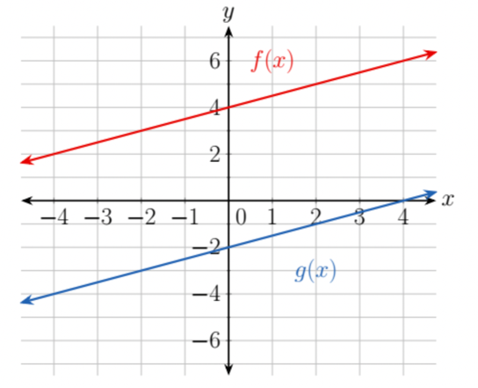
1/2
What is the slope of $f(x)$ and $g(x)$?

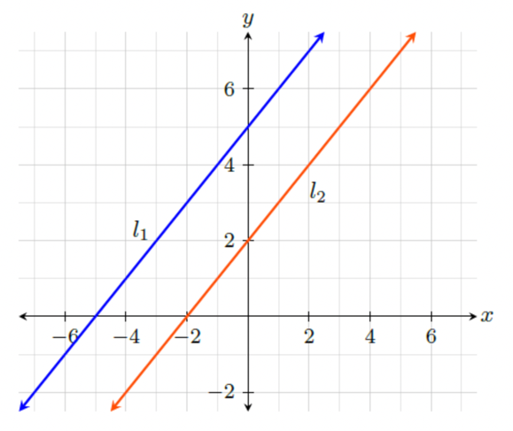
- Given the following graph, write the equation of the line $l_{1}$ using slope-intercept form.
$$y=x+5$$

- Given the following graph, determine the slope of $l_{2}$.
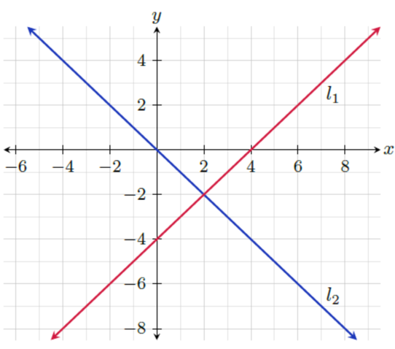
-1

